Computer Architecture and Organization Mid Term Exam
Individual examination n logic circuits [and or not] bread boarding
Build and show output for 1 34 minutes.
a | 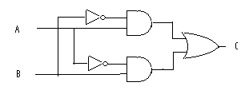 | b | 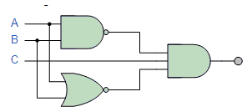
 | 7404 7408 7432 |  | 7400 7432 7408
c | 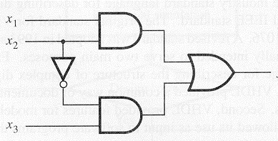 | d | 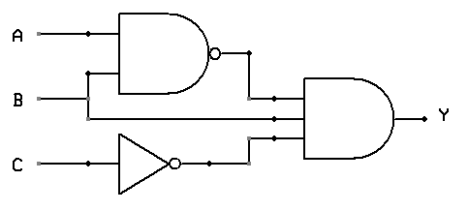
 | 7404 7408 7432 |  | 7400 7432 7408
e | 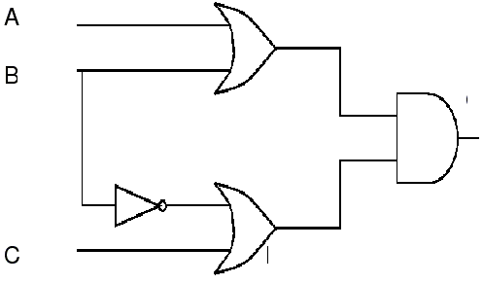 | F | 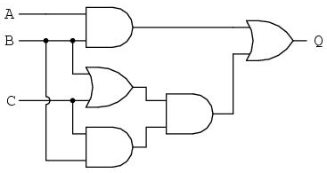
 | 7404 7408 7432 |  | 7432 7408
 | 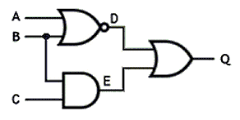 |  | 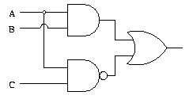
 | 7432 7408 7404 |  | 7400 7432 7408

Schedule of midterm exam: individual
Tuesday, July 21 2015
G0 Marquez Banisil
G1 Templado, J. , Palma
G2 Ramos Madridondo
G3 Mier Delig
G4 Conde Elechicon
G5 Guab Rullete
G6 Sorilla Dulay
G7 Tarong Corpuz
G0 Marquez Banisil
G8 Miraflor Renz Miraflor Ronn
G9 Langrio, Galapon
G10 Melano Salvatiera
Thursday, July 23 2015
G0 Salazar Francisco
G1 Villanueva Allanic
G2 Llorada Joromat
G3 Tempaldo M Desoyo
G4 Masukol Orilla
G5 Montero Marangit
G6 Mangkot Pilar
G7 Hayuhay Lucero
G8 Quinonez Gulle
G9 Niera Vacalanes
G10 Belda Edano
Friday, July 24 2015
G0 Dalisay
G1 Javier
G2 Erier
G3 David
G4 Saludares
G5 Loqueno
G6 Jomahali
G7 Eslao
G8 Mejos
G9 Libot Lacerna
G10 Omega Pabon Caballero

Group shall perform logic circuit bread board and logic proofing.

